Library Management System

|  |  |  |
| --- | --- | --- |
| **Name** | **Roll Number** | **Class & Section** |
| Paladugu Sirivanth | AP18110010245 | CSE-D |

# Aim / Objective:

The main aim and objective of our project is, it’s a web-based application where students can reserve/request a book and whenever they are free they can go and get it from the library. The main intent for designing and developing this project is to maintain a computerized detail of the books present in the library. And the interface helps the students to check the availability of the book in advance without going to the library.

# Sample Scenario:

Let us consider an example where a student wants to get a book from the library but he doesn't know whether the book is available in the library or not then he can check the book availability from this web based application. When the book is available the student can make a request on the application and get it from the library when he is free.

# Who can use this application in real life:

This application can be used as an interface between the student and librarian in the school/college library.

### Note: Admin refers to the Librarian and Reader refers to the students/faculty

Requirements Specification:

Introduction:

As the population increases, the number of people wanting to access the library increases. The volume of people to manage increases by day. We need to build a proper online library management system to be able manage such volumes. As most of the people are utilising the internet facility, we have developed an online library management system website. This includes the facilities like borrowing a book, recommending a book to the librarian (if not available), renewing the return date for a borrowed book, etc. The main purpose of the website is easy

communication between the readers and the librarian, in terms of issuing or returning the books. It shows the author(s) of the book, number of copies available in the library. It also shows the amount of fine to be paid by the reader if any delay in returning the book.

Software Requirements:

Operating system: Windows, MAC Database: MySQL

Language: CSS, JQuery, PHP, SQL Server: Apache

## Hardware Requirements:

512 MB RAM, Pentium P3/P4, 20/40 GB Hard disk

## Design and Implementations Constraints:

All the information of the students must be stored in a database that must be accessible to the Library Management System. As the Library Management system is imposed in an educational institution, it must get connected to the institution’s server and should also have access to the institution's internet facility. The user can access the Library Management System from any computer/laptops/mobiles/tabs/iPad that has stable internet connect and browsing facilities. The credentials that are to be entered by the user at the time of login must match with the credentials that are entered at the time of sign up.

## Functional Requirements:

1. Login/Sign Up:

At first, if the user is new to the website, then he/she must sign up on the website by providing the necessary details

according to the requirements asked. Note: Here the user can be either admin or reader(student/faculty)

If the user has already registered into the Library Management System, he/she can enter the required credentials to login into the system.

### If the User is a Reader (Student/Faculty):

* 1. After getting logged in to the website the reader can see a dashboard with various options. The reader can edit his/her profile.
  2. In the ALL BOOKS section, the reader can view all the available books in the Library and there is a scope for seeing the details of the books and the reader can also request for the issue of a particular book.
  3. In the PREVIOUSLY BORROWED BOOKS section, the reader can view all the previously borrowed books.
  4. In the RECOMMENDED BOOKS section, the reader can recommend a book if needed to the admin by providing the title of the book and a small description of it.
  5. In the CURRENTLY ISSUED BOOKS, the reader can view all currently issued books.

### If the User is an Admin:

* 1. After getting logged in to the website the admin can see a dashboard with various options. The admin can edit his/her profile.
  2. In the MANAGE STUDENTS section, the admin can view the details of those students who have already signed up into the Library Management System.
  3. In the ALL BOOKS section, the admin can view all the details of the available books in the library and can also update the number of copies of the available books.
  4. In the ADD BOOKS section, the admin can add the new entries of the books.
  5. In the ISSUE/RETURN/RENEW section, the admin can either issue the requested book to the reader or accept the return book request by the reader or accept the renewed book request by the reader.
  6. In the BOOK RECOMMENDATIONS section, the admin can view all the recommended books by the reader.
  7. In the CURRENTLY ISSUED section, the admin can view all the currently issued books and also the fine (if any).

1. Log Out:

If all the necessary work is done by both the admin and the reader, he/she can logout from the website by clicking on the logout button.

## Non - Functional Requirements:

Usability Requirement:

The user can access the Library Management System from any computer/laptops/mobiles/tabs/iPad that has stable internet connect and browsing facilities. The Library Management System is a user friendly website.

Availability Requirement:

The system is open to the customer at all times and can be used 24 hours a day, 365 days a year. The system must be available 24 hours a day, seven days a week.

Efficiency Requirement:

Mean Time to Repair: If the system ever fails, It will be recovered within no time.

Accuracy:

The system can have reliable real-time data when taking into account different concurrency problems. The system must have connectivity efficiency of 100 percent.

Performance Requirement:

Based to whether or not the application has been updated, the material is refreshed. From the moment the request is sent, the device must answer to the member in less than two seconds. When doing big production tasks, the machine should be able to take more time. Responses to display details must appear on the screen in less than 5 seconds.

Reliability Requirement:

Because of the value of data and the potential harm that missing or inaccurate data can inflict, the system must be completely accurate. The system will be operational 24 hours a day, seven days a week.

# Use case:

|  |  |
| --- | --- |
| **Use Case Selection** | **Description** |
| Use Case name | Add student and Admin record |
| Level | Sub-Functional level |
| Primary actor | Student, Admin |
| Stakeholders and interest | Admin: 1. wants to register into the system.  2. responsible for the management of the transaction of fine and also login and register details.  Student: wants to register into the system. |
| Pre-condition | 1. Students and Admin have submitted their registration form. |
| Post-condition | Record for a student/Admin has been added. |
| Main success scenario | 1 Student/Admin opens the application to access the services of the LMS.  2 Student/Admin sign-up to get registered online.  3 He/She provides correct information and secret passwords.  4 He/She got registered. |
| Alternative flow | 1 Student/Admin opens the application in their phone 2 He/She tries to sign-up  3 He/She fails and receives an error  4 He/She will report an error and the error will be rectified as soon as possible. |
| Specific requirement | * The response time for registration is 1 minute.   + The response time for login is 1 minute |

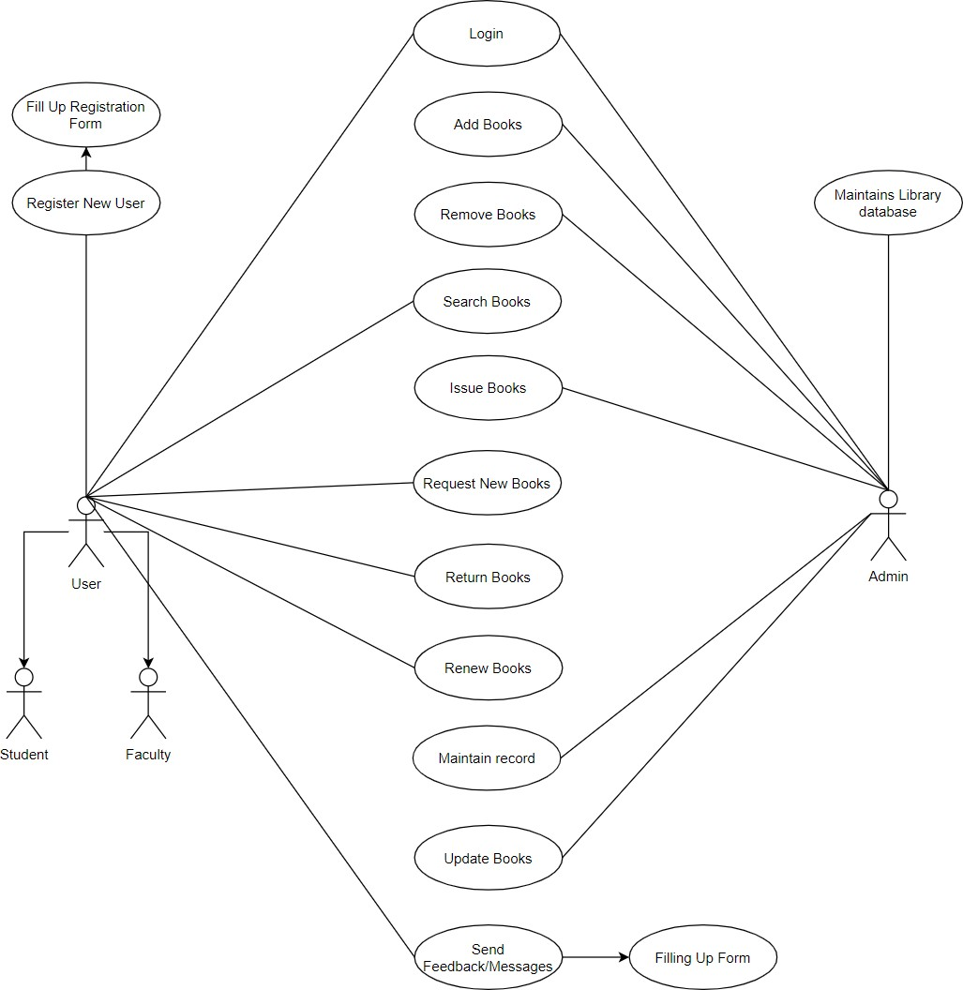

1. Level DFD:

*For Admin:*

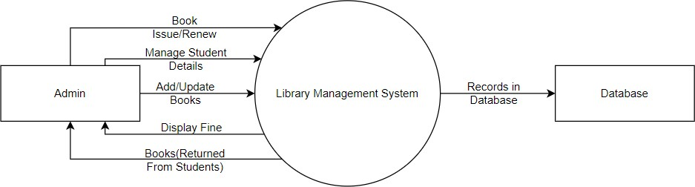

*For Student:*

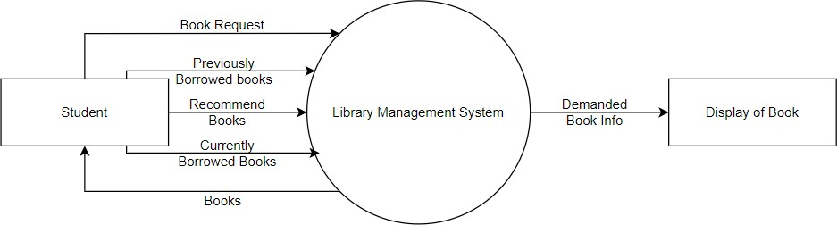

# Level DFD:

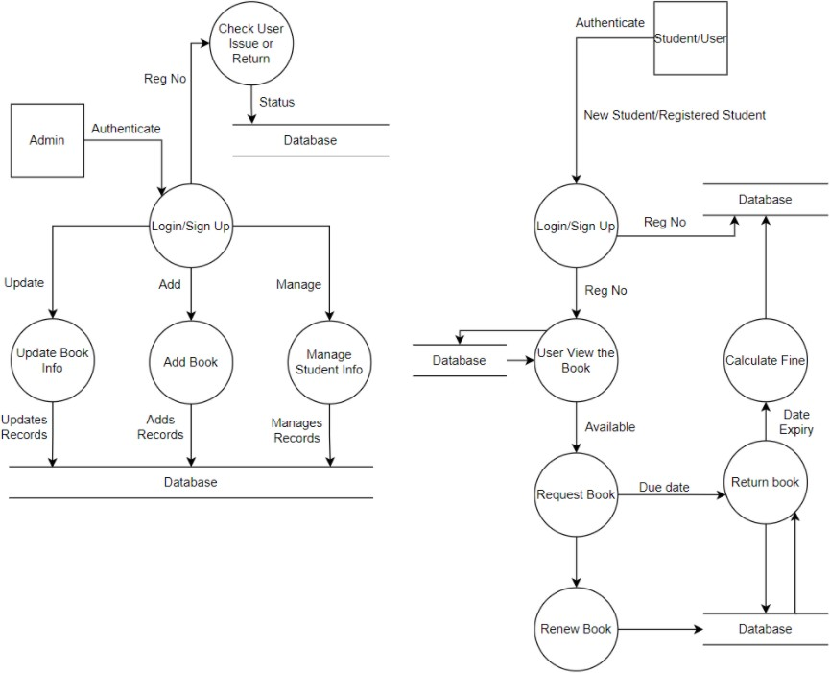

Data Dictionary:

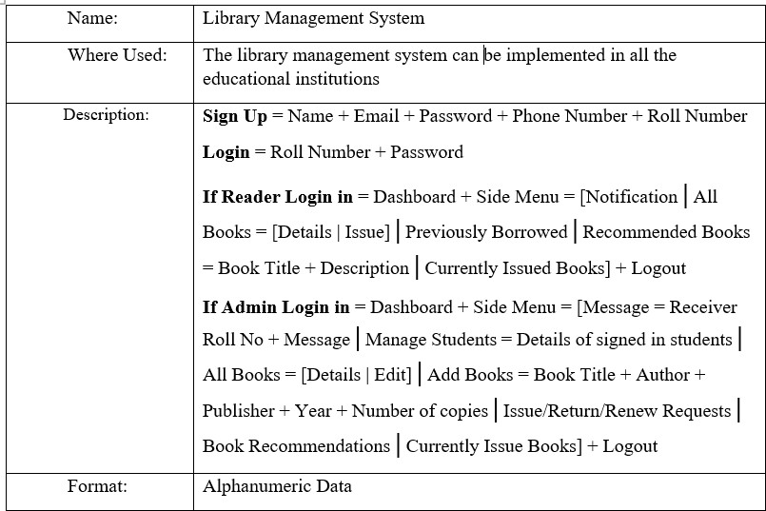

Structured Chart:

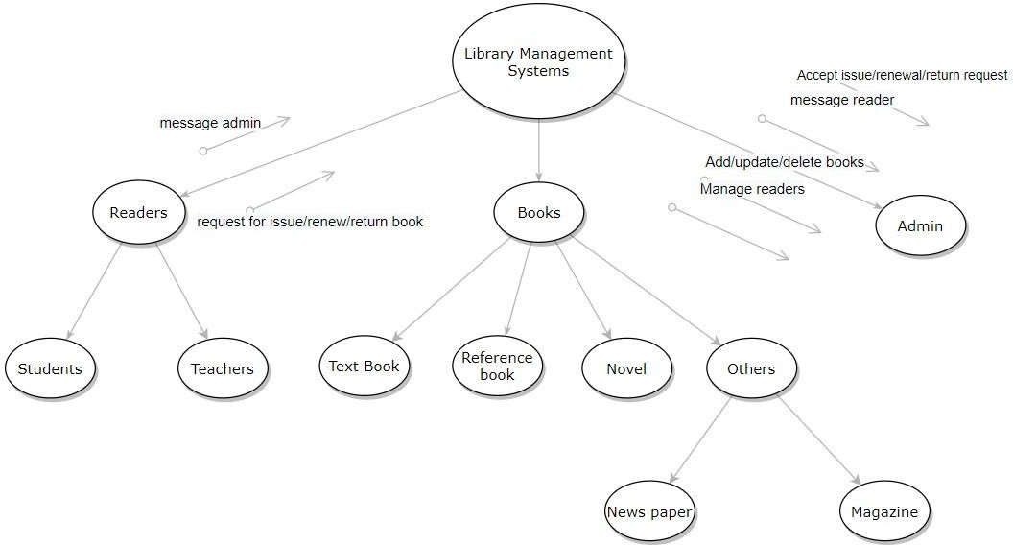

Class Diagram:-

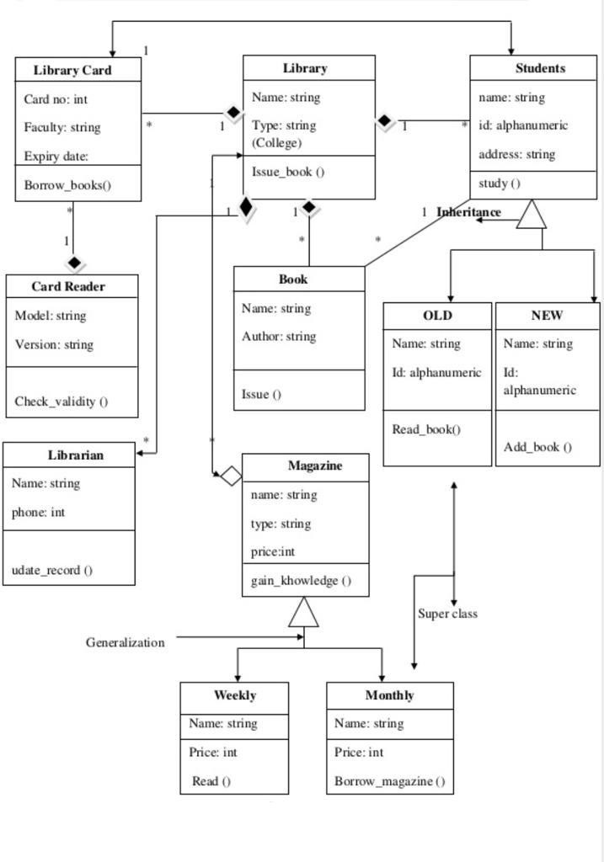

For denoting one element we use **1**, for zero elements we use **0**, and for many elements we use **\***.

# Object Diagram:-

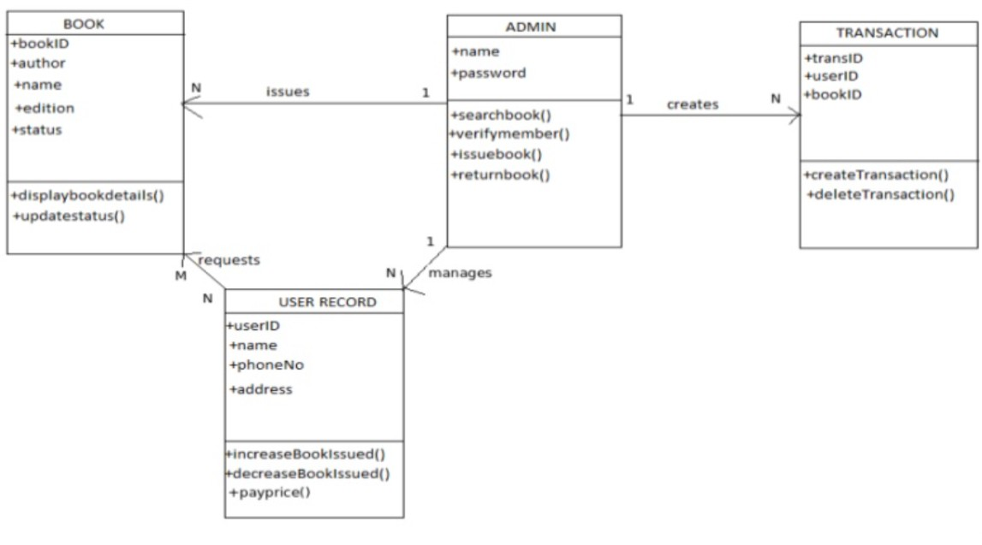

Sequence Diagram:-

*For issuing book:*

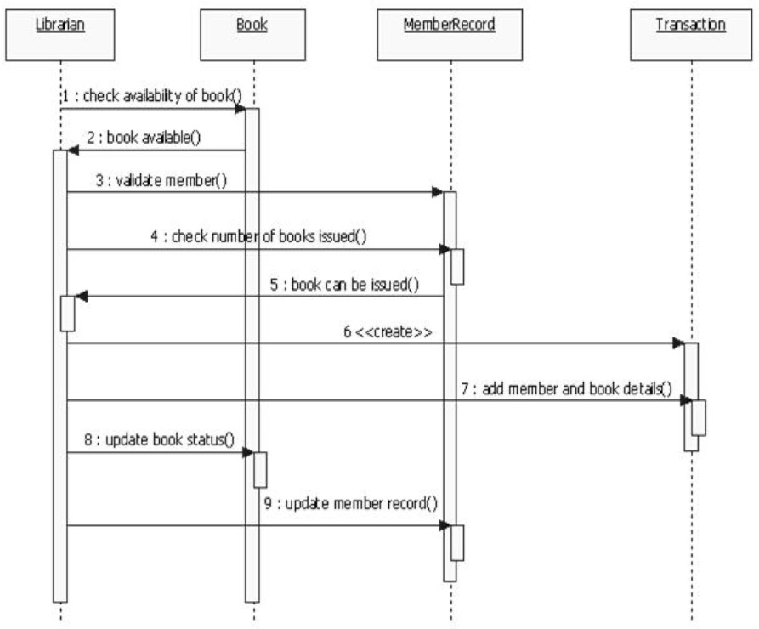

*For returning book:-*

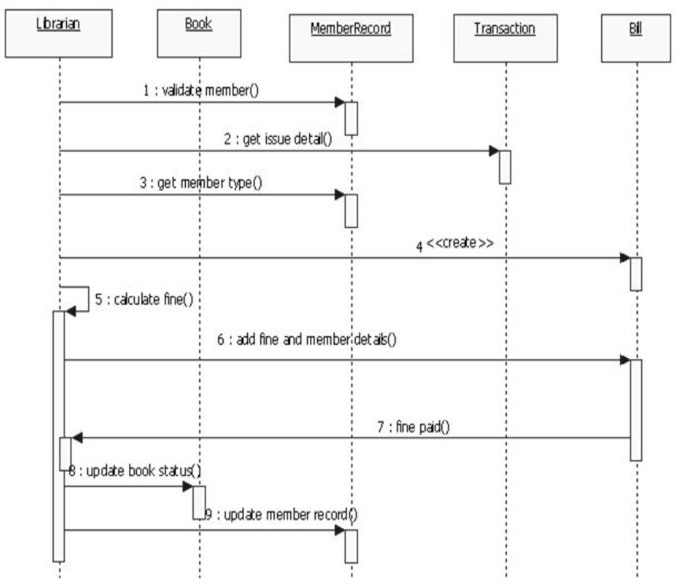

# Collaboration Diagram:-

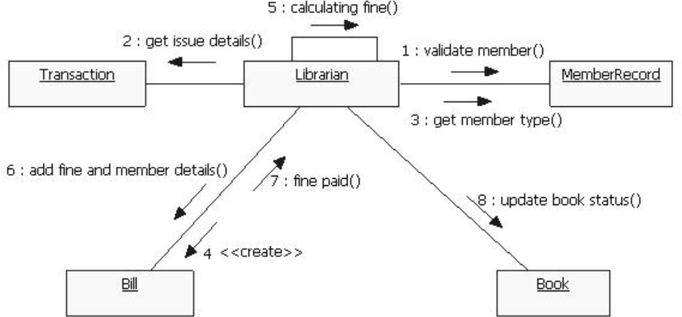

State Chart Diagram:-

*For Student:-*

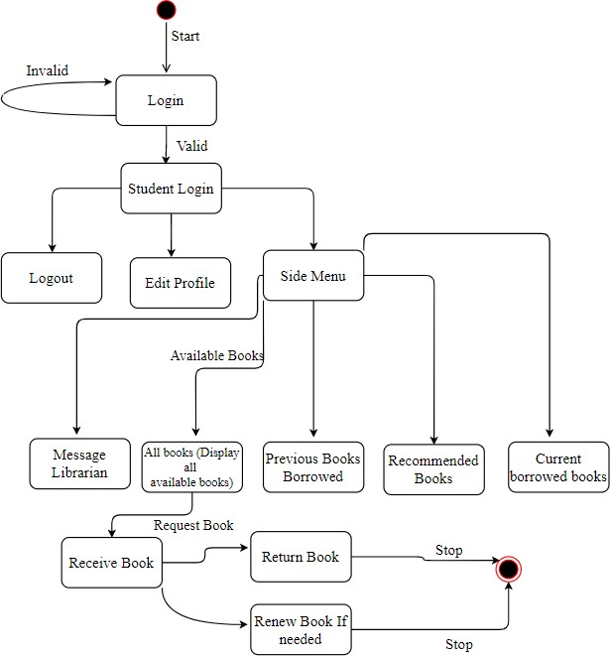

*For Admin:-*

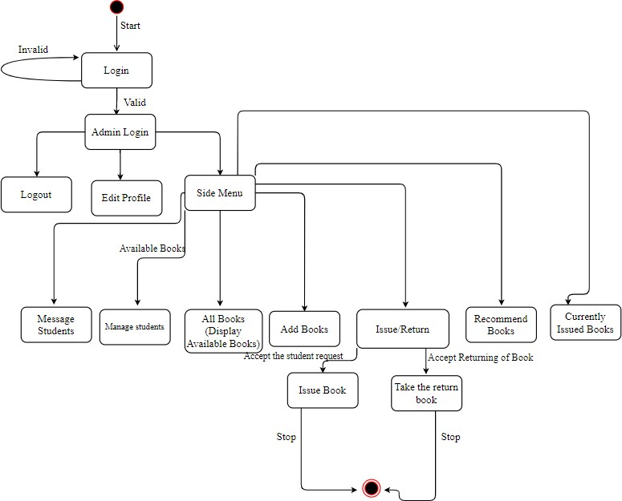

# Activity Diagram:-

*For issuing a book:-*

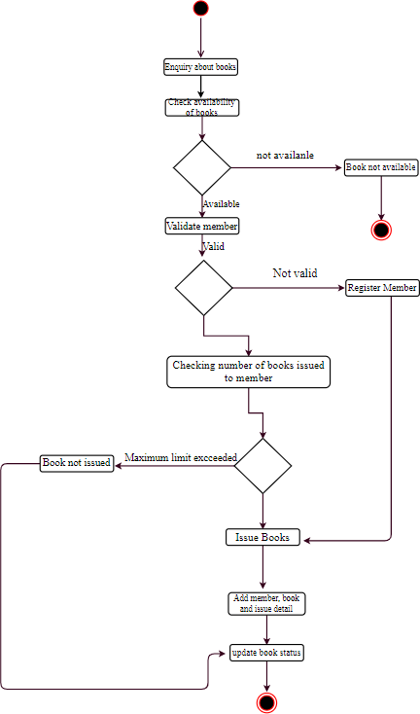

*For returning a book:-*

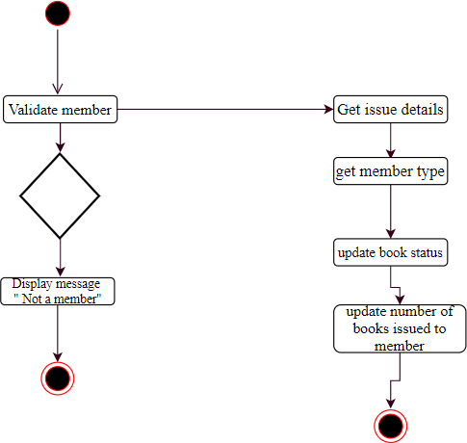

# Component Diagram:-

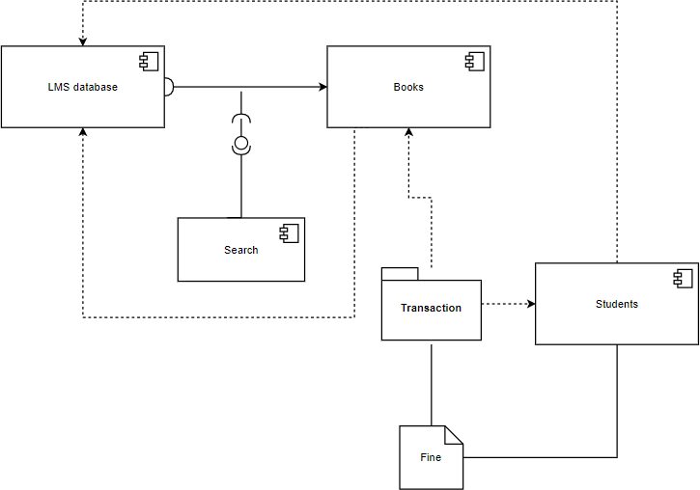

Deployment Diagram:-

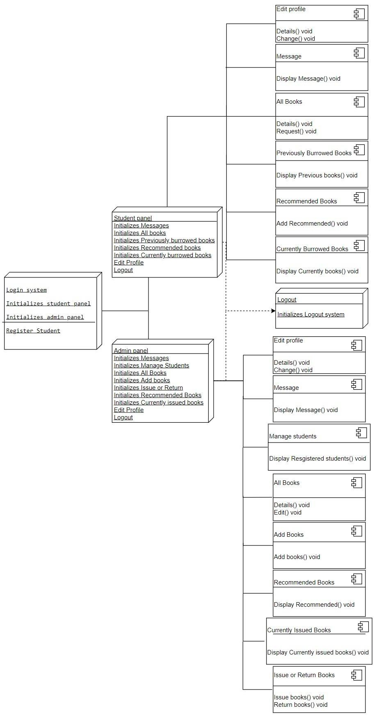

Unit Testing:

Sign In/Sign Up:

|  |  |  |  |
| --- | --- | --- | --- |
| **Step** | **Action** | **Expected System Response** | **Pass/Fail** |
| 1. | Enter Roll No | The System accepts the Roll No | Pass |
| 2. | Enter Password | The System accepts the password | Pass |
| 3. | Click On Sign In Button | The System displays home page | Pass |
| 4. | Enter Name | The System accepts the Name | Pass |
| 5. | Enter Email Id | The System accepts the Email Id | Pass |
| 6. | Enter Password | The System accepts the password | Pass |
| 7. | Enter Phone Number | The System accepts the Phone No | Pass |
| 8. | Enter Roll No | The System accepts the Roll No | Pass |
| 9. | Select the Caste | The System accepts the Caste | Pass |
| 10. | Click On Sign Up Button | The System displays registration successful and redirects to Sign In | Pass |

## If Reader Log into the Website

Home Page:

|  |  |  |  |
| --- | --- | --- | --- |
| **Step** | **Action** | **Expected System Response** | **Pass/Fail** |
| 1. | Click on Edit Details | Redirects the page to edit details | Pass |
| 2. | Click on Messages | Redirects the page to edit Messages | Pass |
| 3. | Click on All Books | Redirects the page to All Books | Pass |
| 4. | Click on Previously borrowed Books | Redirects the page to Previously Borrowed Books | Pass |
| 5. | Click on Recommended Books | Redirects the page to Recommended Books | Pass |
| 6. | Click on currently Issued | Redirects the page to Currently | Pass |

|  |  |  |  |
| --- | --- | --- | --- |
|  | Books | Issued Books |  |
| 7. | Click on Logout | Redirects the page to Sign In | Pass |

Messages:

|  |  |  |  |
| --- | --- | --- | --- |
| **Step** | **Action** | **Expected System Response** | **Pass/Fail** |
| 1. | No action | Displays all Messages/Notifications | Pass |

All Books:

|  |  |  |  |
| --- | --- | --- | --- |
| **Step** | **Action** | **Expected System Response** | **Pass/Fail** |
| 1. | Enter Name/Id of Book | The system accepts the Name/Id of Book | Pass |
| 2. | Click on Search Button | The system displays the result for search | Pass |
| 3. | Click on Details Button | The system displays Book Details | Pass |
| 4. | Click on Issue Button | The System displays Request Sent to Admin and redirects to All Books | Pass |

Previously Borrowed Books:

|  |  |  |  |
| --- | --- | --- | --- |
| **Step** | **Action** | **Expected System Response** | **Pass/Fail** |
| 1. | Enter Name/Id of Book | The system accepts the book name | Pass |
| 2. | Click on Search Button | The system displays the result for search | Pass |
| 3. | No action | The system displays Previously Borrowed Books | Pass |

Recommend Books:

|  |  |  |  |
| --- | --- | --- | --- |
| **Step** | **Action** | **Expected System Response** | **Pass/Fail** |
| 1. | Enter Title | The system accepts the Title | Pass |
| 2. | Enter Description | The system accepts the Description | Pass |
| 3. | Click on Submit Recommendation | The system displays Success and redirects to recommend books | Pass |

Currently Issued Books:

|  |  |  |  |
| --- | --- | --- | --- |
| **Step** | **Action** | **Expected System Response** | **Pass/Fail** |
| 1. | Enter Name/Id of Book | The system accepts the book name | Pass |
| 2. | Click on Search Button | The system displays the result for search | Pass |
| 3. | Click on Renew Button | The system displays Request Sent to Admin and redirects to Currently Issued Books | Pass |
| 4. | Click on Return Button | The system displays Request Sent to Admin and redirects to Currently Issued Books | Pass |

## If Admin Log into the Website

Home Page:

|  |  |  |  |
| --- | --- | --- | --- |
| **Step** | **Action** | **Expected System Response** | **Pass/Fail** |
| 1. | Click on Edit Details | Redirects the page to edit details | Pass |
| 2. | Click on Messages | Redirects the page to edit Messages | Pass |
| 3. | Click on Manage Students | Redirects the page to Manage Students | Pass |
| 4. | Click on All Books | Redirects the page to All Books | Pass |

|  |  |  |  |
| --- | --- | --- | --- |
| 5. | Click on Add Books | Redirects the page to Add Books | Pass |
| 6. | Click on Issue/Return Requests | Redirects the page to Issue/Return Requests | Pass |
| 7. | Click on Book Recommendations | Redirects the page to Book Recommendations | Pass |
| 8. | Click on currently Issued Books | Redirects the page to Currently Issued Books | Pass |
| 9. | Click on Logout | Redirects the page to Sign In | Pass |

Messages:

|  |  |  |  |
| --- | --- | --- | --- |
| **Step** | **Action** | **Expected System Response** | **Pass/Fail** |
| 1. | Enter Roll No | The system accepts the Roll No | Pass |
| 2. | Enter Message | The system accepts message | Pass |
| 3. | Click on the Add Message Button | The system displays Success and redirects to Messages | Pass |

Manage Students:

|  |  |  |  |
| --- | --- | --- | --- |
| **Step** | **Action** | **Expected System Response** | **Pass/Fail** |
| 1. | Enter Name/Roll No of Student | The system accepts the Name/Roll No of Student | Pass |
| 2. | Click on Search Button | The system displays the result for search | Pass |
| 3. | Click on Details Button | The system displays the details of the student | Pass |

All Books:

|  |  |  |  |
| --- | --- | --- | --- |
| **Step** | **Action** | **Expected System Response** | **Pass/Fail** |
| 1. | Enter Name/Id of Book | The system accepts the book name | Pass |

|  |  |  |  |
| --- | --- | --- | --- |
| 2. | Click on Search Button | The system displays the result for search | Pass |
| 3. | Click on Details Button | The system displays Book Details | Pass |
| 4. | Click on Edit Button | The System displays a form to update the book details | Pass |

Add Books:

|  |  |  |  |
| --- | --- | --- | --- |
| **Step** | **Action** | **Expected System Response** | **Pass/Fail** |
| 1. | Enter Title | The system accepts the book title | Pass |
| 2. | Enter Author | The system accepts the book author | Pass |
| 3. | Enter Publisher | The system accepts the book publisher | Pass |
| 4. | Enter Year | The system accepts the book year | Pass |
| 5. | Enter Number of Copies | The system accepts the book copies | Pass |
| 6. | Click on Add Book Button | The system displays success and redirects to Add Books | Pass |

Issue/Return Requests:

|  |  |  |  |
| --- | --- | --- | --- |
| **Step** | **Action** | **Expected System Response** | **Pass/Fail** |
| 1. | Click on Issue Requests | The system displays list of issue requests | Pass |
| 2. | Click on Renew Requests | The system displays list of renew requests | Pass |
| 3. | Click on Return Requests | The system displays list of return requests | Pass |

Issue Requests:

|  |  |  |  |
| --- | --- | --- | --- |
| **Step** | **Action** | **Expected System Response** | **Pass/Fail** |
| 1. | Click on Issue Requests | The system displays list of issue requests | Pass |
| 2. | Click on Renew Requests | The system displays list of renew requests | Pass |
| 3. | Click on Return Requests | The system displays list of return requests | Pass |
| 4. | Click on Accept | Accepts the request | Pass |
| 5. | Click on Reject | Rejects the request | Pass |

Renew Requests:

|  |  |  |  |
| --- | --- | --- | --- |
| **Step** | **Action** | **Expected System Response** | **Pass/Fail** |
| 1. | Click on Issue Requests | The system displays list of issue requests | Pass |
| 2. | Click on Renew Requests | The system displays list of renew requests | Pass |
| 3. | Click on Return Requests | The system displays list of return requests | Pass |
| 4. | Click on Accept | Accepts the request | Pass |

Return Requests:

|  |  |  |  |
| --- | --- | --- | --- |
| **Step** | **Action** | **Expected System Response** | **Pass/Fail** |
| 1. | Click on Issue Requests | The system displays list of issue requests | Pass |
| 2. | Click on Renew Requests | The system displays list of renew requests | Pass |
| 3. | Click on Return Requests | The system displays list of return requests | Pass |

|  |  |  |  |
| --- | --- | --- | --- |
| 4. | Click on Accept | Accepts the request | Pass |

Book Recommendations:

|  |  |  |  |
| --- | --- | --- | --- |
| **Step** | **Action** | **Expected System Response** | **Pass/Fail** |
| 1. | No action | The system displays the list of book recommendations from students | Pass |
| 3. | Click on Add a Book | The system Redirects to Add Books | Pass |

Currently Issued Books:

|  |  |  |  |
| --- | --- | --- | --- |
| **Step** | **Action** | **Expected System Response** | **Pass/Fail** |
| 1. | Enter Roll No students/Book Name/Book Id | The system accepts the Roll No of students/Book Name/Book Id | Pass |
| 2. | Click on Search Button | The system displays the result for search | Pass |
| 3. | No action | Displays the list of currently issued books | Pass |

# Integration Testing:

|  |  |  |  |  |
| --- | --- | --- | --- | --- |
| **Step** | **Test Step** | **Expected Result** | **Actual Result** | **Test Result** |
| 1. | When a student fills the necessary fields in the recommend books, the  recommended books by the reader can be seen in the book  recommendations section on admin | The Recommended books should be seen on the admin in the book recommendations section | The admin is able to see the recommendations made by the readers | Pass |
| 2. | When admin sends a message to the  reader the message will be delivered to the reader even though that particular reader is not logged into the website | The reader should receive the message  even though the reader is logged out | The reader received the message sent by the  admin | Pass |
| 3. | When reader makes a request(book  request, renew request, return request) to the  admin, the request can be seen on  admin portal in the Issue/Return  requests section | The admin should be able to see the requests  made by the readers | The admin received all the requests in the  Issue/Renew Requests section | Pass |
| 4. | When admin updates the book  copies, the updates can be seen on the readers portal on the all books section | The readers should be able to see the updates made by the admin in the all books section | The updates were seen in the all books section | Pass |
| 5. | When admin adds new books, they | The readers should be able to see the new | The new books were seen in the all books | Pass |

|  |  |  |  |  |
| --- | --- | --- | --- | --- |
|  | can be seen on the readers portal in the  all books section | books in the all books section | section |  |